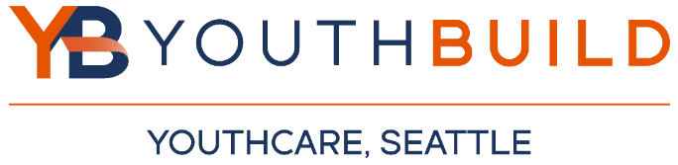

YouthBuild Referral Form
South Seattle Community College, Georgetown Campus
6737 Corson Avenue South, Building B, Seattle, WA 98108
Phone: (206) 295-3081 Email: troy.hayman@youthcare.org
Youth Name: ___________________Email: _________________________ Phone: __________________________

Staff Making Referral: Referring Program/Organization: ______________________________

Referring Staff Email: Referring Staff Phone Number: ________________________________

Reason for Referral: ________________________________________________________________________________________________

Client Age:
Client Birthday:
Does client have a GED or HSD? YES / NO
Client is interested in the following career: (Circle one or all that applies)

*Laborer *Carpenter *Welder *Electrician *Plumber *Cement Mason *Flagger *Other/Undecided:

